SAP Application Development

(S/4 HANA)

SAP FIORI

Motivation  In this chapter you will get in contact with tiles, catalogs and groups, configure your own SAP FIORI Launchpad, create semantic objects and roles in the SAPGUI and use them to assign certain tiles to applications and transactions in the Launchpad Designer, using target mapping. | Prerequisites  You have created a package and a Transport request  It is recommended that you have completed the SAPUI5 Chapter
Content  This chapter explains the basic principles of SAP FIORI, how to configure and personalize a Launchpad. | Lecture notes  -

- Product: All

- Level: Advanced

- Focus: Programming

- Version: 1.0

- Author: UCC Technical University of Munich

Task 1: Get in contact with basic navigation
Short description: Create a catalog, group and role

Unlike the previous exercises, customization of a Fiori launchpad happens in browser. To access the launchpad designer, open the following link:
http://<webdispatchername>/sap/bc/ui5_ui5/sap/arsrvc_upb_admn/main.html

The Launchpad is also accessible in browser using the following link:
http://<webdispatchername>/sap/bc/ui5_ui5/ui2/ushell/shells/abap
/FioriLaunchpad.html

Web dispatcher name should be provided by your instructor. Login with the credentials that you’ve used for the previous exercise.

In the Launchpad designer, make sure you have selected catalogs and press 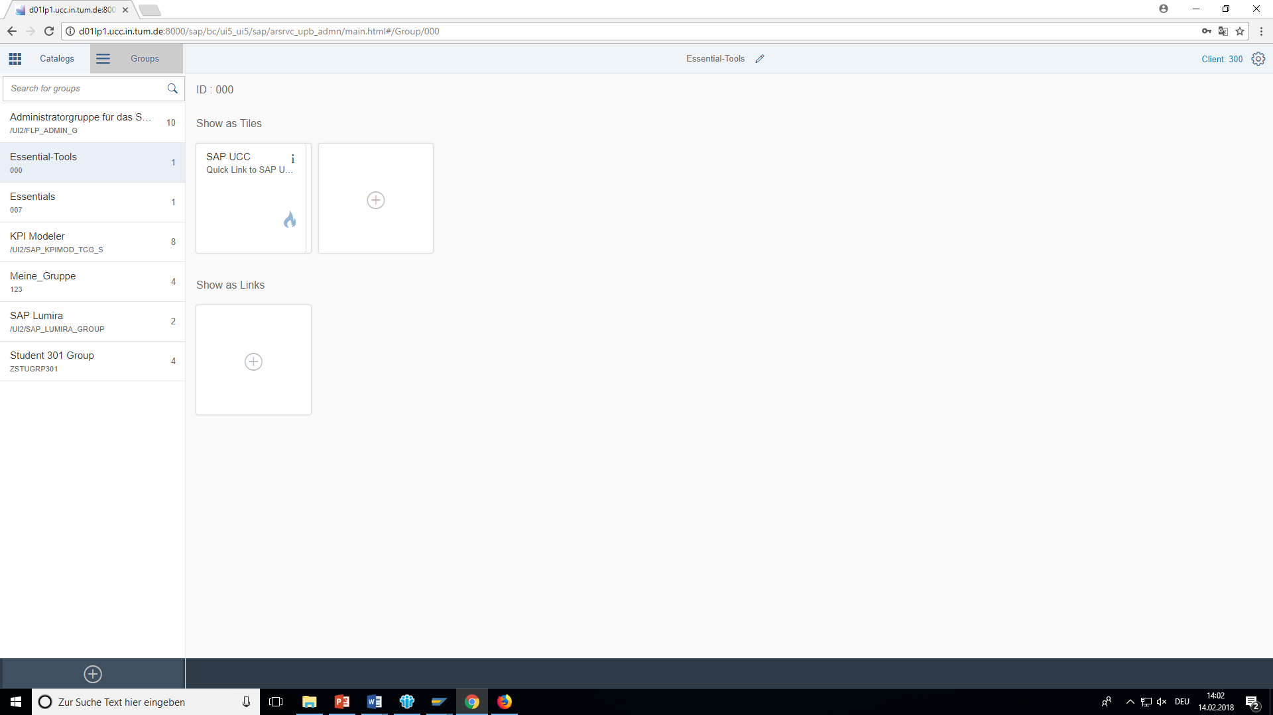 to create a new one. We will collect the tiles, created during this exercise, in here. Make sure to replace $$ with your two-digit institution id and ### with your number in the title and the ID field.
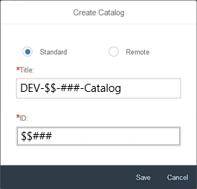
Click on “Add Tile”  to create a new tile. Choose “App-launcher-static”. Fill in the blanks according to the screenshot below and press save afterwards. This will create your first tile, a simple navigation to a website of your choice.
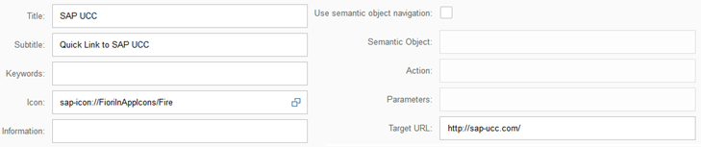
To gain access to the tile, it is necessary to create a role to which the catalog will be assigned. Use the transaction PFCG in the SAP GUI or in the integrated GUI in Eclipse, type in a role name (replace 000 with your number) and select single role. Go to User tab and enter your User ID, to assign the role to you.
Subsequently go to Menu tab and follow the path Transaction -> SAP Fiori Tile Catalog.
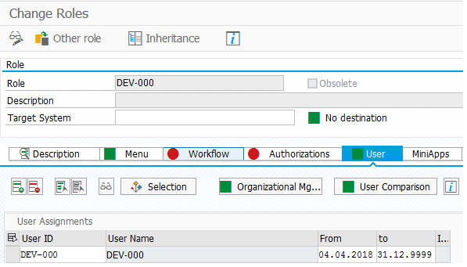
Type in the ID you have given your catalog earlier on ($$###) and confirm your selection.
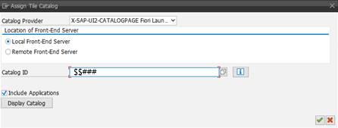
Save your role and return to the SAP Menu.

Go back to the Fiori Launchpad in browser and switch to the Groups tab. Press  to create a new group. Use your number instead of 000 both in the title and the id. Leave the checkbox to allow personalization checked.
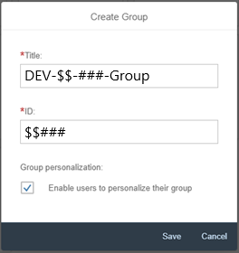

Now you can assign tiles to your group. During the configuration process you have access to all tiles of all catalogs, but for now only choose the one tile from your catalog. You can add a tile to the group by clicking on the plus sign below it.
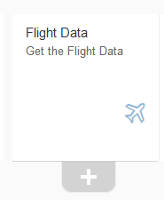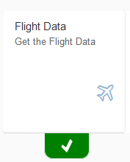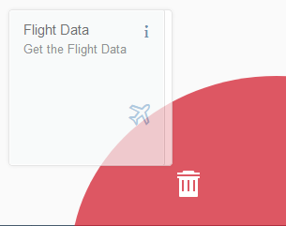

You can delete tiles by keeping them pressed and dragging them to the bin appearing in the lower right corner.

Open the PFCG transaction again. Go to the Menu Tab and follow the path Transaction -> SAP Fiori Tile Group. Choose your group in the pop-up window and confirm your selection. Save your role.

Now open your Launchpad, and you will now see the tiles, assigned to your group. It is also possible to add the tiles from the catalog. It can be done by going to the me-area , selecting 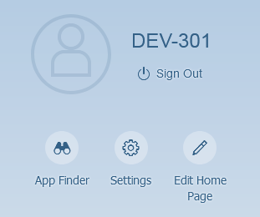 and choosing the respective application by clicking on the pin button . For now, however, you do not have any other catalogs assigned to you.

Task 2: Use navigation by intent (at the example of URL)
Short description: Navigation, using semantic objects

Opposed to the navigation by URL you used in the last task the intent-based navigation is recommended, because it decouples the navigation trigger and the navigation target.

An intent consists of a semantic object and an action. The action can have an arbitrary name (usually a verb), the semantic object on the other hand has to be defined before it can be used. Therefore, we are first going to create one. Call the transaction /n/UI2/SEMOBJ, switch to change mode 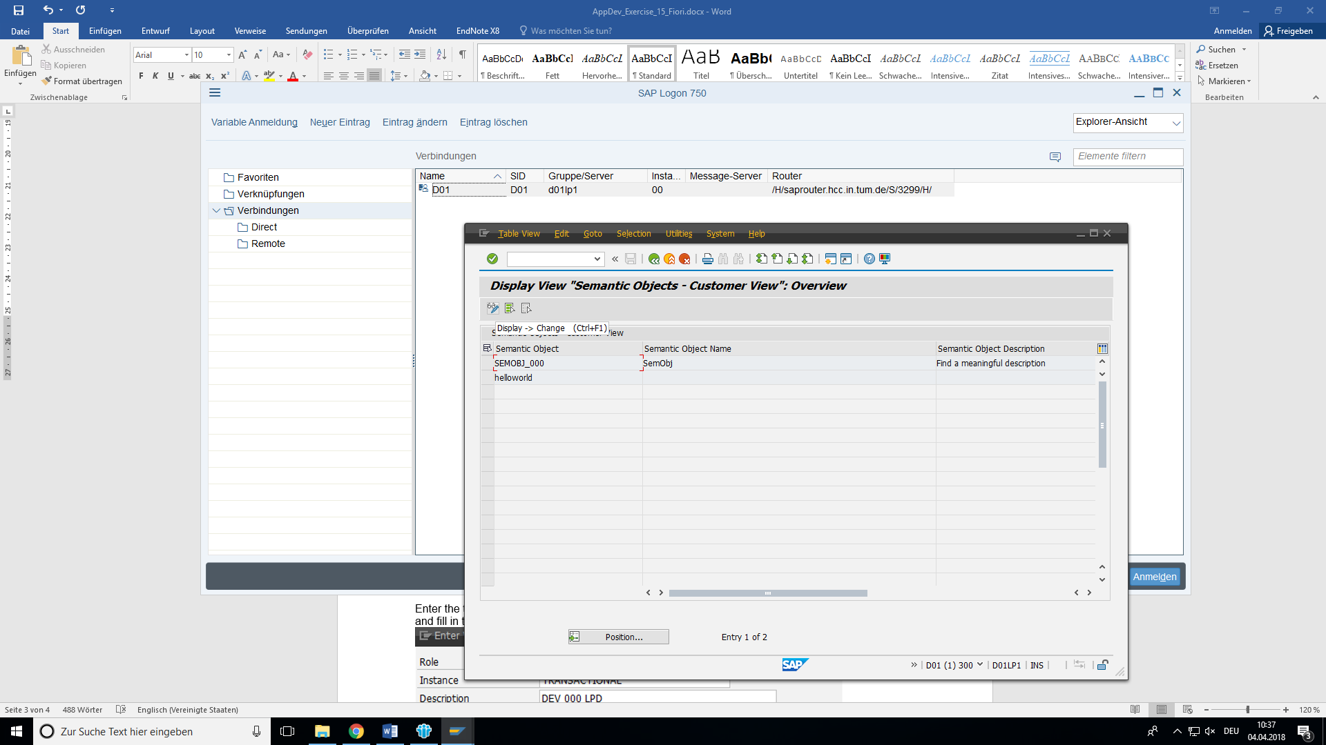 , ignore the warning and press new entries.

Further, you will have to type in a meaningful name and description. Save your changes afterwards.
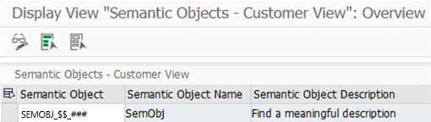

Now go to the launchpad designer, select your catalog and create a new tile. Choose the static app launcher, type in the title and subtitle like you did in Task one, choose an appropriate icon, and keep the checkbox “use semantic object navigation” selected. Search your new semantic object with the input help, pick a fitting action (e.g. display) and .
Change to the target mapping configuration page 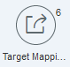.

Create a new target mapping, fill in the semantic object and action you used in the previous step (defining the new tile). On the right side you can choose an application type.

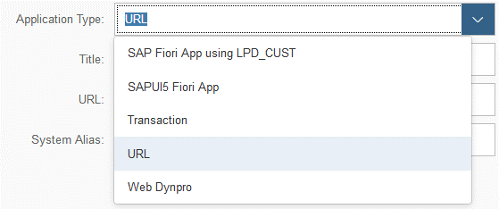

You will be guided through all of them in the following exercise. For this task it is sufficient to choose application type URL and enter a link of your choice.
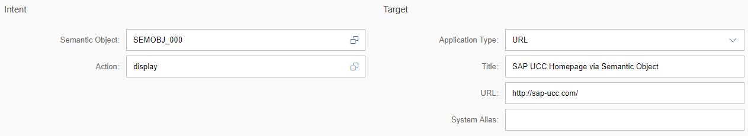
In the example we are using the link to SAP UCC homepage again. Save your target mapping. After that assign the new tile to your group. You will see both tiles when you reload the Fiori launchpad (you might need to perform a hard reload or clear the browser cache if it does not work at once).

Task 3: Application types
Short description: Configuring the navigation based on the application type

The following exercises are independent and can be dealt with separately. Each is dedicated to one of the application types (and its corresponding target mapping configuration). Create a new semantic object for each of them, otherwise they could interfere with one another. Also keep in mind that you have to reassign (using the PFCG transaction) the tile catalog and the tile group to your role every time you create a new tile or assign it to the tile group.

3.1 SAPUI5 Fiori App

First, we have to differentiate. Not all SAPUI5 applications are Fiori apps. The UI5 app has to be specifically developed as a Fiori component to be used that way. Navigation via URL (Task 2) can be used for the non-Fiori UI5 apps. Another alternative would be to use LPD_CUST transaction, but this way is obsolete on the S/4 HANA System.

Since the UI5 applications that we developed in the previous two exercises are Fiori app, we can include them into the Launchpad. For that, create a target mapping as follows:
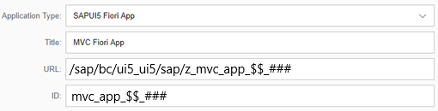
Do not forget to replace the ### with your number. Save your target mapping. After that create a static tile like shown in the first exercise. Populate the “General” section asdepicted below:
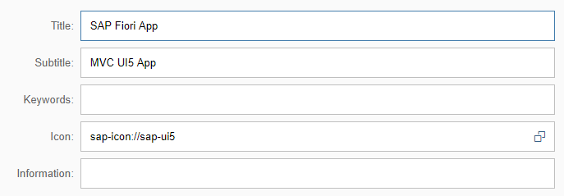
Finally, specify the navigation properties:
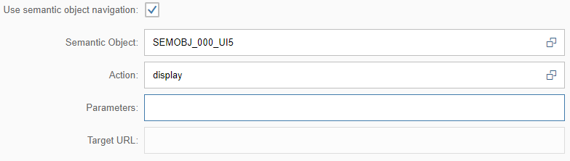
Save your tile and add it to your group. After you reload your Fiori Launchpad, you should see the new tile.

3.2 Transaction

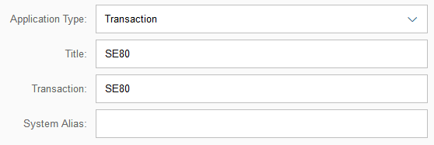
The common way is to create the target mapping, selecting the application type transaction and maintaining the Title and the Transaction (e.g. SE80).
After you’ve saved the target mapping you can create a tile and add it to your group.
An alternative would be to use navigation via URL (like in task 1) or navigation by intent with URL as application type (task 2). The URL in this case is the path to the transaction that can open it in the WebGUI. To find out the URL, navigate to SICF transaction. Enter /sap/bc/gui/sap/its/webgui as the Service Path and and press F8 ( ).
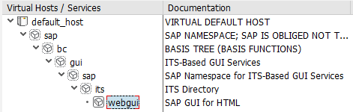
Select the webgui node, right click on it and click on “Test Service” to execute it. You will get a security alert, asking you to confirm the service execution and showing the URL. You can modify the URL to directly call transaction SE80.
The final URL should look like this:
http://<Server-name>:port/sap/bc/gui/sap/its/webgui?~TRANSACTION=SE80

You can use it when creating a tile with URL navigation or when defining a target mapping based on the URL. Nevertheless, it is recommended to stick to the way mentioned above and to define a target mapping, based on the transaction.
3.3 Web Dynpro

For the Web Dynpro we use the standard hello_world application, delivered by SAP. Feel free to use your own Web Dynpro if you already created one. Create a target mapping as depicted on a screenshot below.

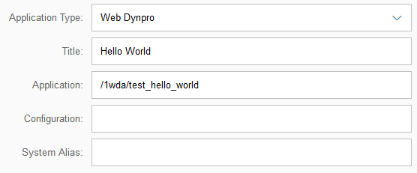
Save it, create a tile using this target mapping, and add it to your group.
3.4 News Tile:
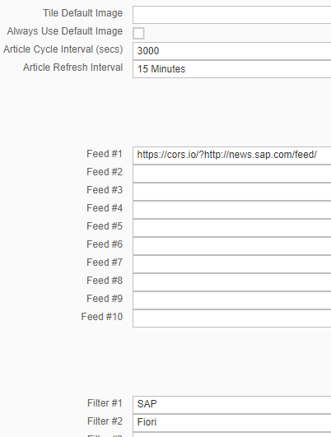
The news tile enables you to display rss feeds within your launchpad. You simply refer to the source and add filters as further restrictions what kind of content should be displayed. Create a new tile like in the task 1 but choose “News Tile” instead of “App-launcher static”. Set the cycle interval to 3000 seconds and keep the refresh interval as it is. Enter http://news.sap.com/feed/ as Feed #1. If you saved your tile right now, you would get the error: “No 'Access-Control-Allow-Origin' header”. This happens if you are referring to a link in another namespace, and your browser does this solely for security reasons (Same-origin-policy). Therefore, you will have to add a proxy or use CORS (Cross-Origin Resource Sharing). Cors.io is a quick solution to achieve this. Simply add https://cors.io/? in front of your URL (as seen in the screenshot on the right). Save the tile and add it to your group.
3.5 Dynamic App launcher:
Before we create a dynamic app launcher, we need a target mapping for it. So, create a new semantic object and use it when defining a target mapping. Set other parameters as shown on the screenshot and replace 000 with your number.
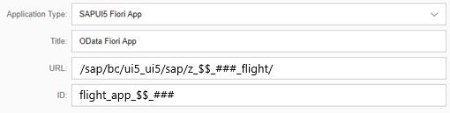
Save your target mapping and create a new tile. Choose “App Launcher - Dynamic” this time. Fill out the “General” section.
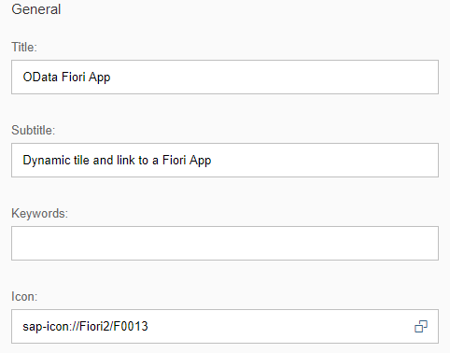
Use your semantic object and specify display as action.
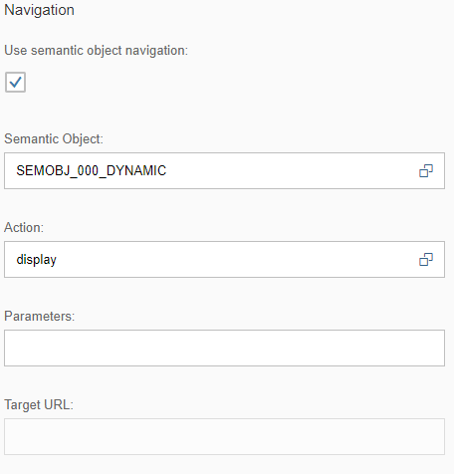
Finally, enter the service URL of your OData service, and set the refresh interval to 60 seconds.
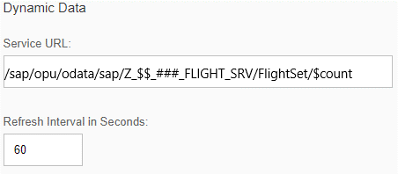
Save your tile and add it to your group. You must be able to see it when you refresh your launchpad. Unlike the other tiles that are only used for navigation, this one will also show you the number of the flights, stored in the database table.
